Pentagon

Definition
# Source: AI Source: Provided by: [Data Path: Persons Table -> ID Column: 1, Name_En Column: Motasem Essam] -> From: [ChatGPT] on [7/25/2026]
A pentagon is a polygon with five sides, five vertices, and five interior angles.
The word pentagon comes from Greek:
- pente = five
- gonia = angle
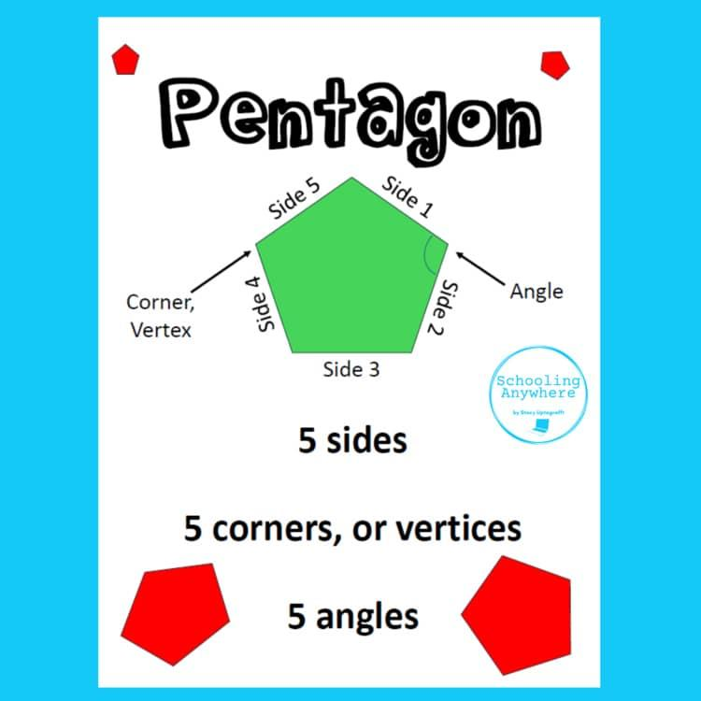
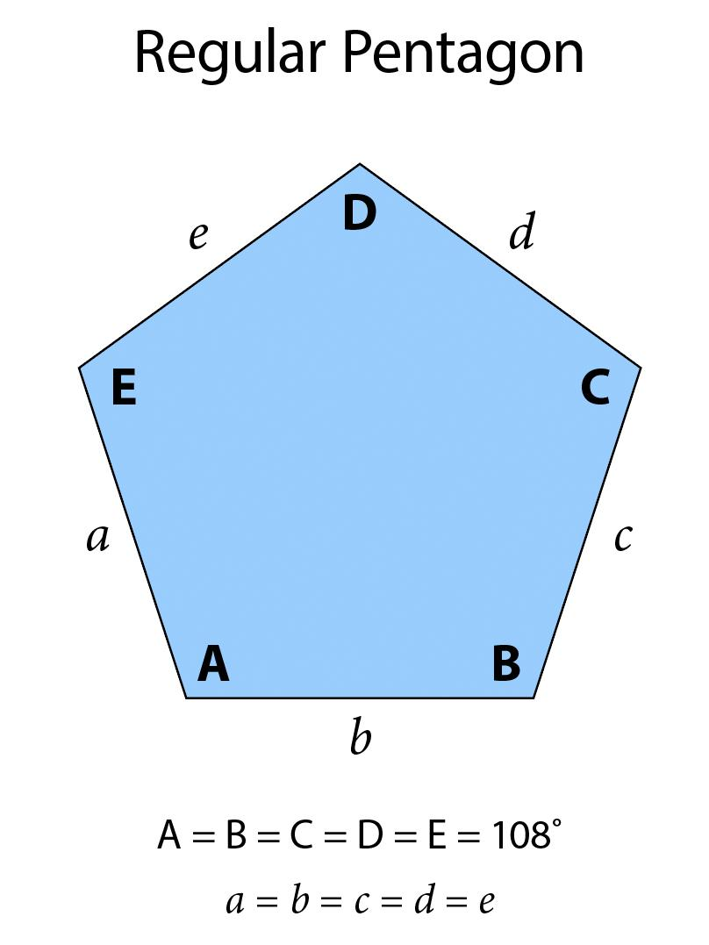
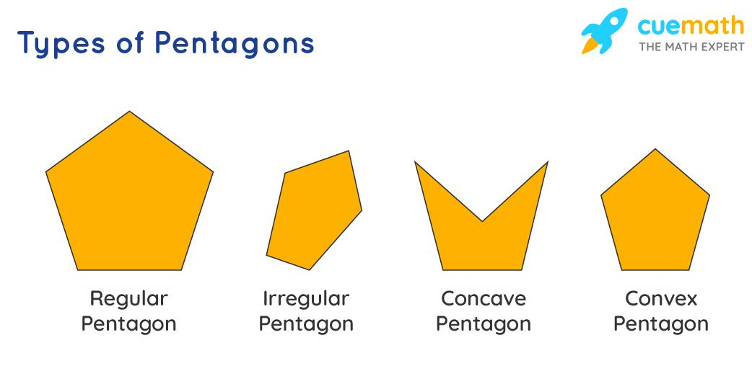
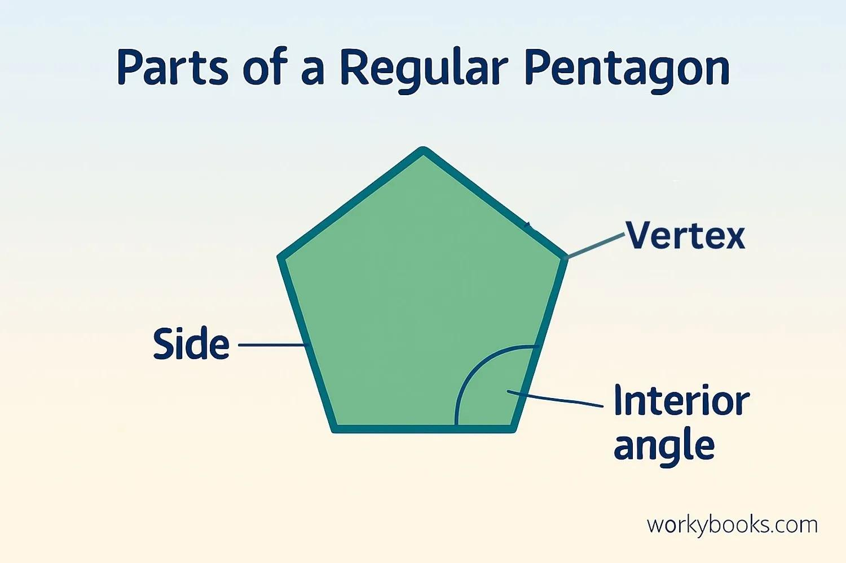
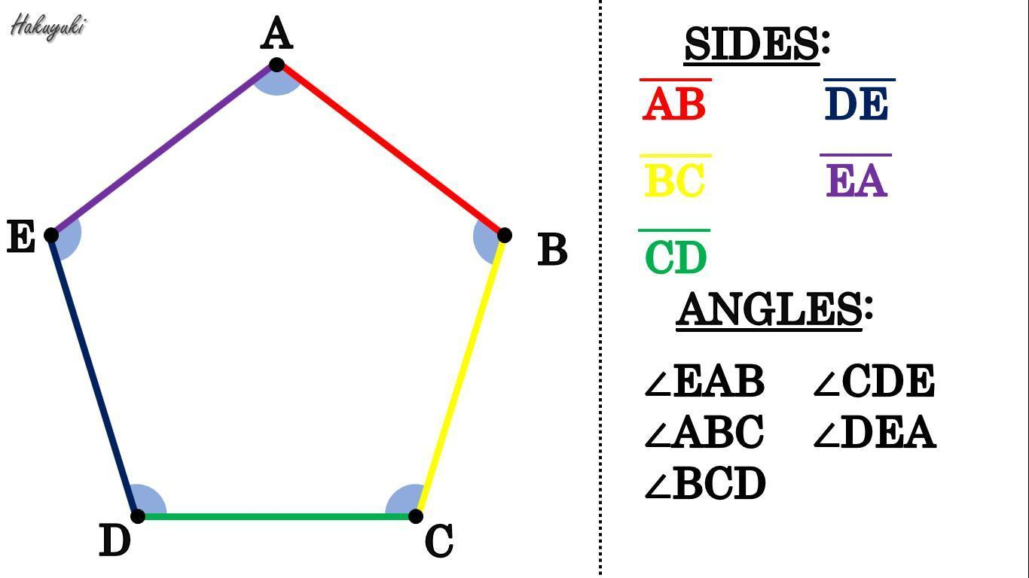

Fundamental Elements
# Source: AI Source: Provided by: [Data Path: Persons Table -> ID Column: 1, Name_En Column: Motasem Essam] -> From: [ChatGPT] on [7/25/2026]
A pentagon has:
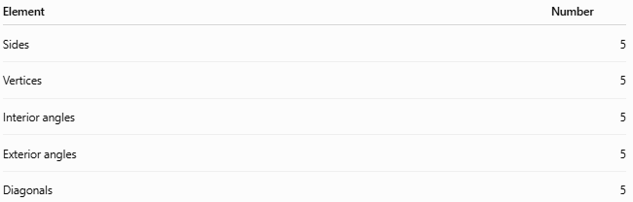
Element | Number
Sides | 5
Vertices | 5
Interior angles | 5
Exterior angles | 5
Diagonals | 5
A pentagon can be labeled:
$$\boxed{ABCDE}$$
Its five sides are:
$$\overset{‾}{AB}, \overset{‾}{BC}, \overset{‾}{CD}, \overset{‾}{DE}, \overset{‾}{EA}$$

Classification of Pentagons
# Source: AI Source: Provided by: [Data Path: Persons Table -> ID Column: 1, Name_En Column: Motasem Essam] -> From: [ChatGPT] on [7/25/2026]
Pentagons can be classified according to several properties.
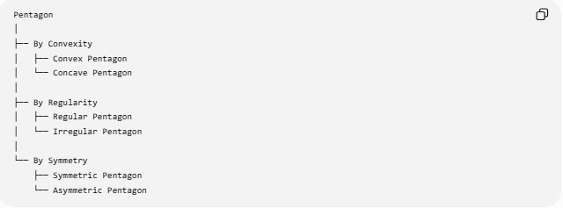
Pentagon
│
├── By Convexity
│ ├── Convex Pentagon
│ └── Concave Pentagon
│
├── By Regularity
│ ├── Regular Pentagon
│ └── Irregular Pentagon
│
└── By Symmetry
├── Symmetric Pentagon
└── Asymmetric Pentagon

Regular Pentagon
# Source: AI Source: Provided by: [Data Path: Persons Table -> ID Column: 1, Name_En Column: Motasem Essam] -> From: [ChatGPT] on [7/25/2026]
A regular pentagon has:
- five congruent sides
- five congruent interior angles
- five congruent exterior angles
- five lines of symmetry
- rotational symmetry of order $5$
Each interior angle is:
$$\boxed{{108}^{∘}}$$
Each exterior angle is:
$$\boxed{{72}^{∘}}$$
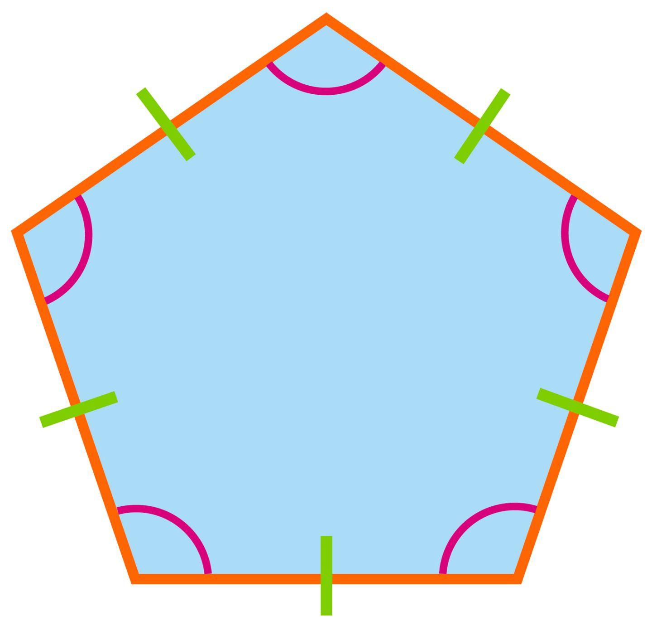
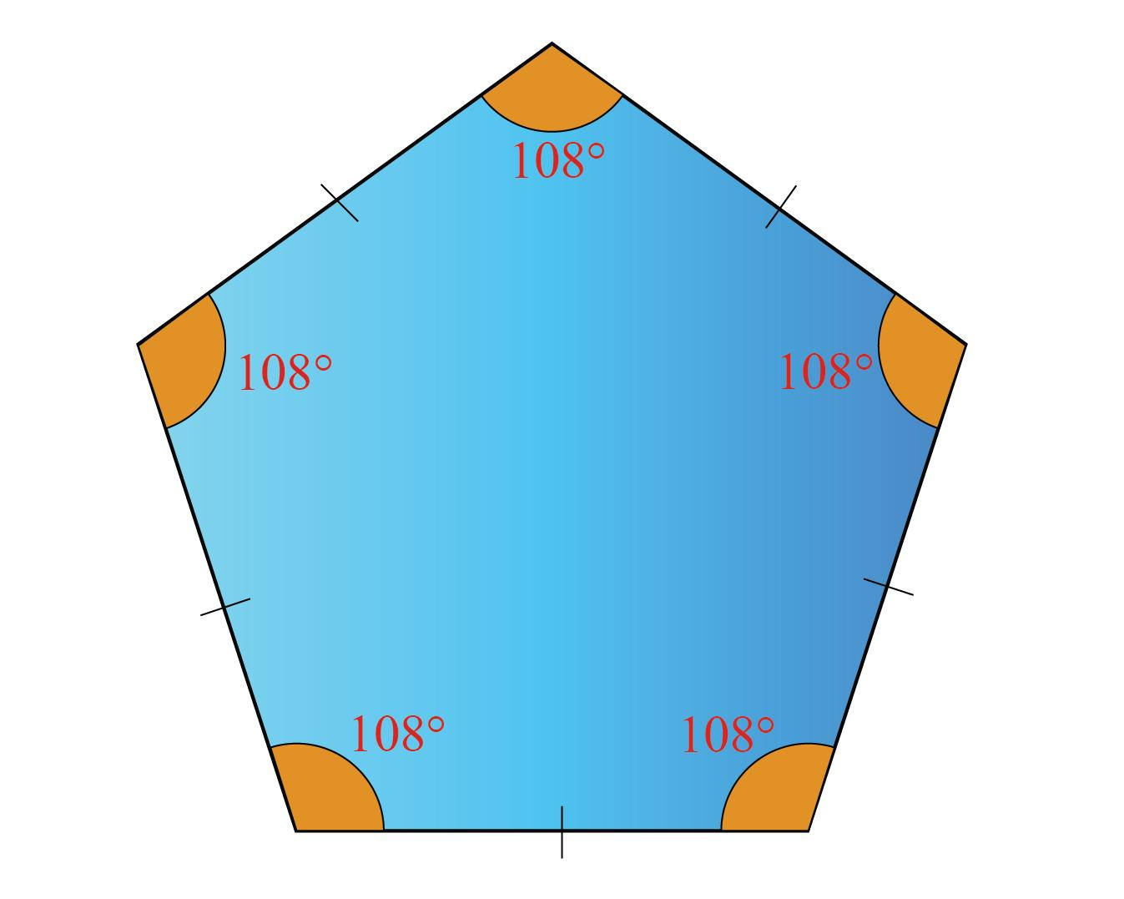
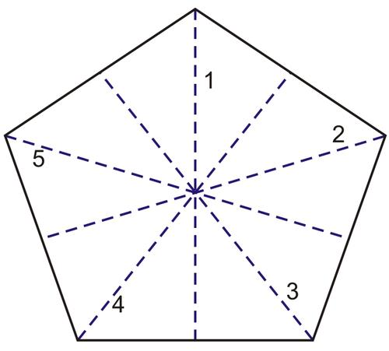
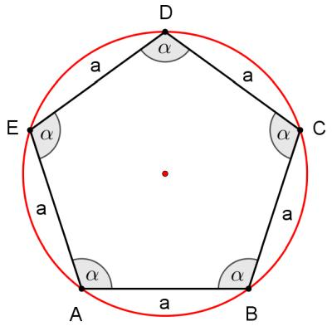
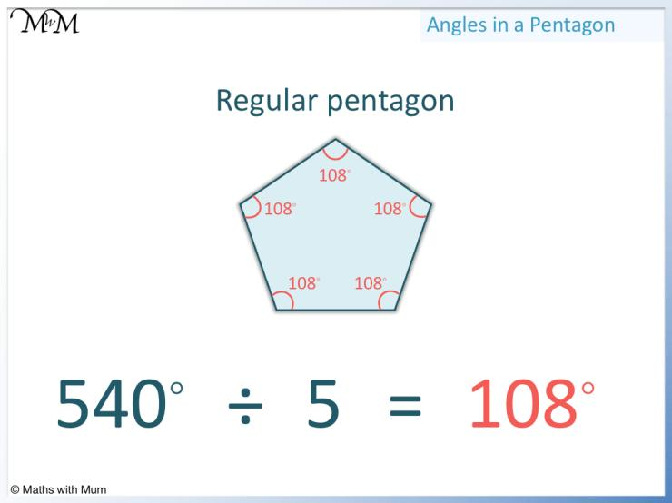
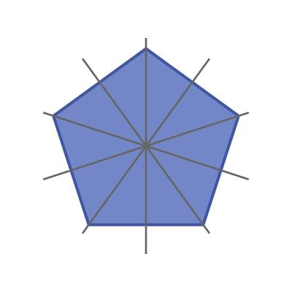

Irregular Pentagon
# Source: AI Source: Provided by: [Data Path: Persons Table -> ID Column: 1, Name_En Column: Motasem Essam] -> From: [ChatGPT] on [7/25/2026]
An irregular pentagon does not have all five sides and angles equal.
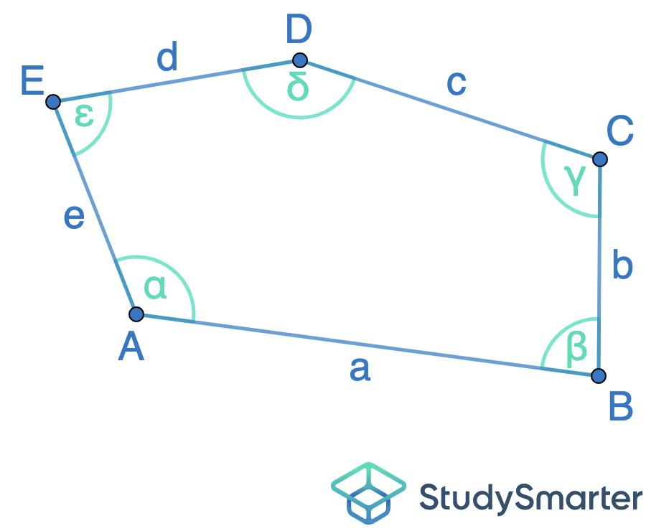
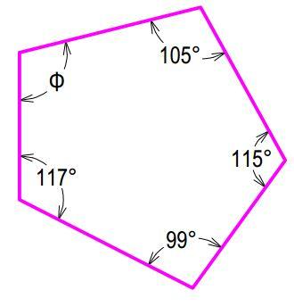
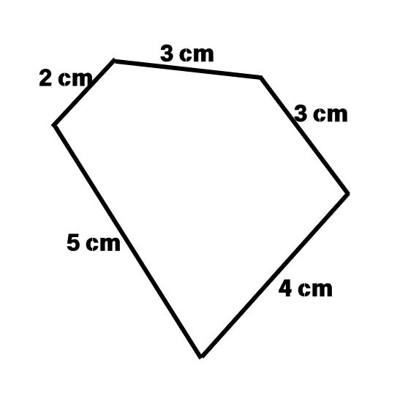
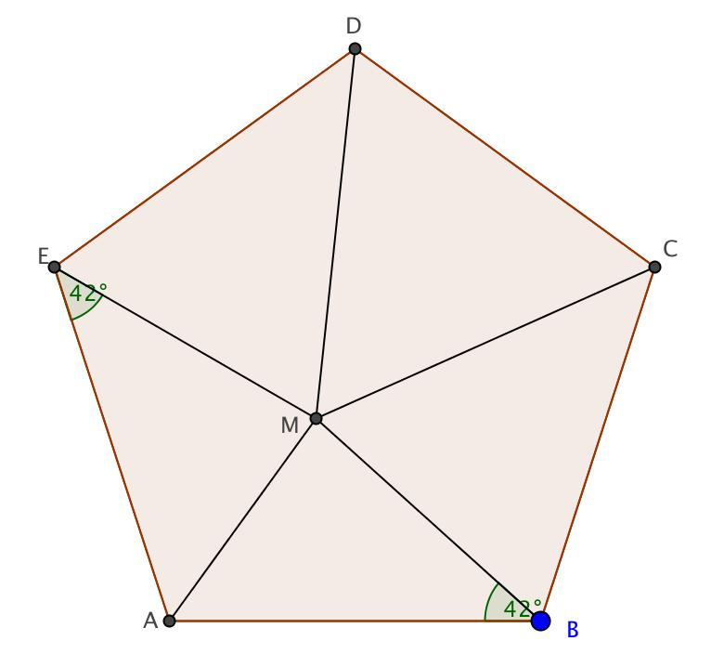
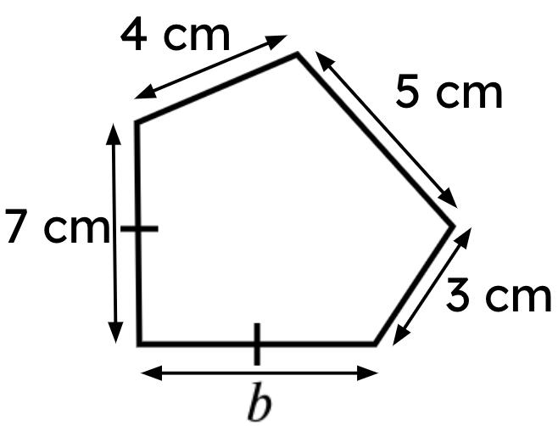

Convex Pentagon
# Source: AI Source: Provided by: [Data Path: Persons Table -> ID Column: 1, Name_En Column: Motasem Essam] -> From: [ChatGPT] on [7/25/2026]
A convex pentagon has:
$$\boxed{\text{every interior angle}<{180}^{∘}}$$
No diagonal lies outside the pentagon.
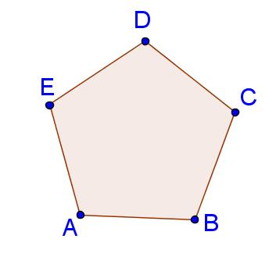
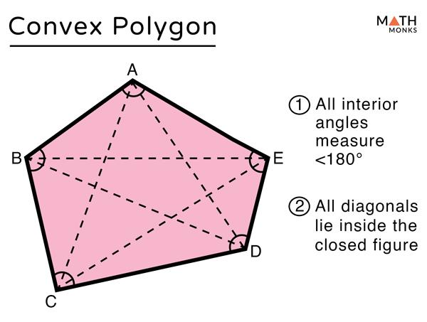
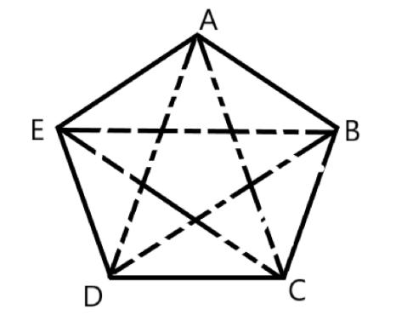
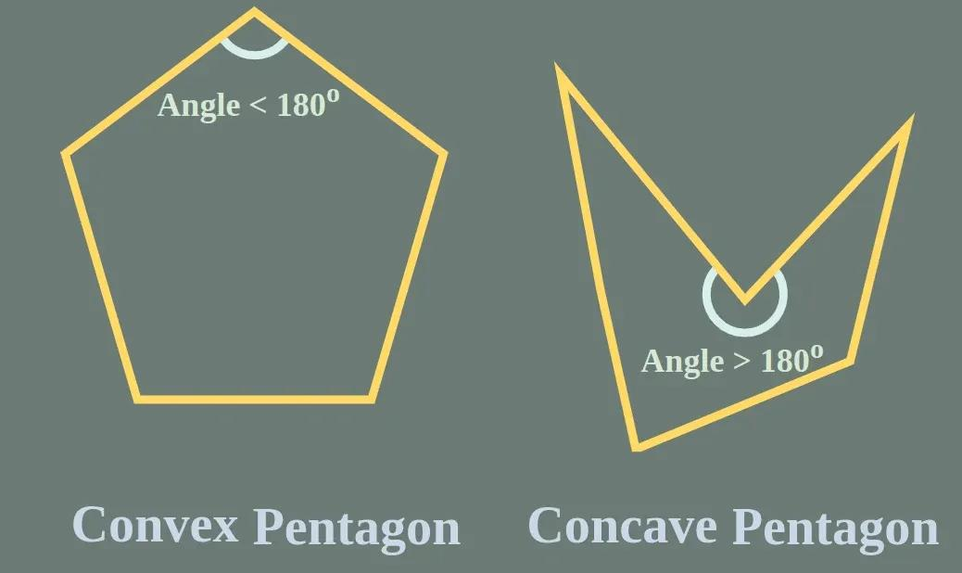
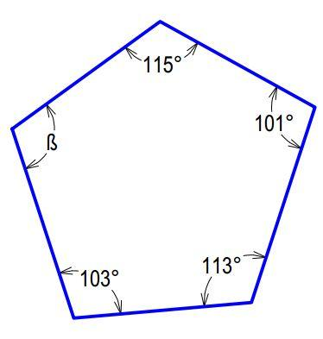
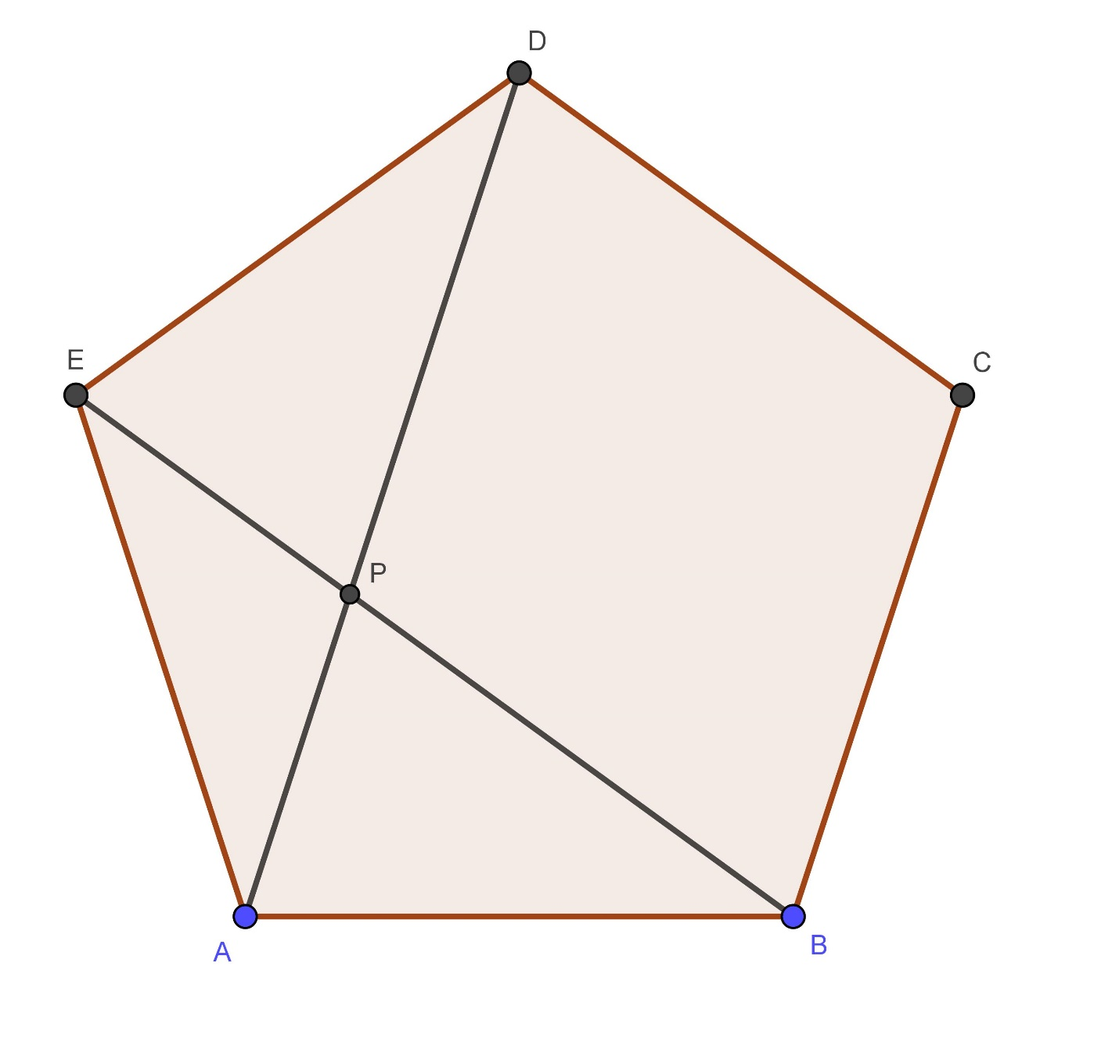

Concave Pentagon
# Source: AI Source: Provided by: [Data Path: Persons Table -> ID Column: 1, Name_En Column: Motasem Essam] -> From: [ChatGPT] on [7/25/2026]
A concave pentagon has at least one interior angle greater than:
$${180}^{∘}$$
It has at least one diagonal lying partly outside the pentagon.
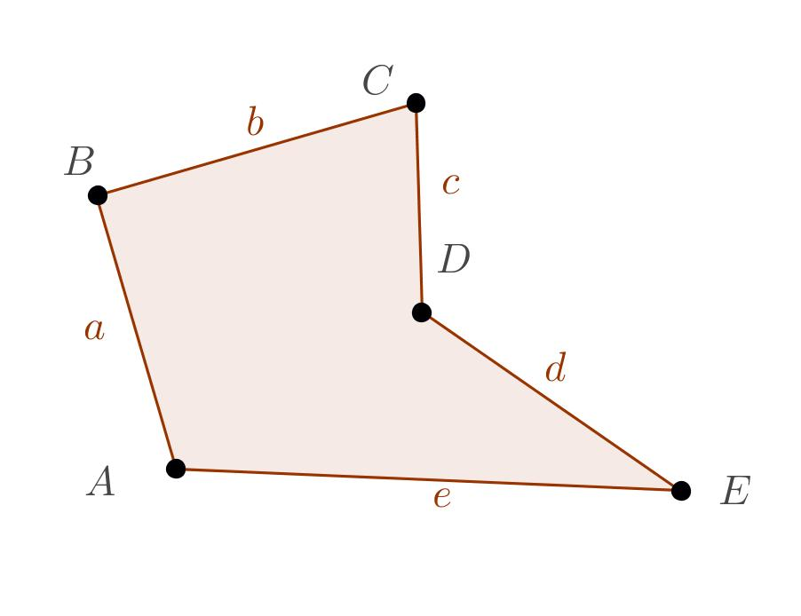
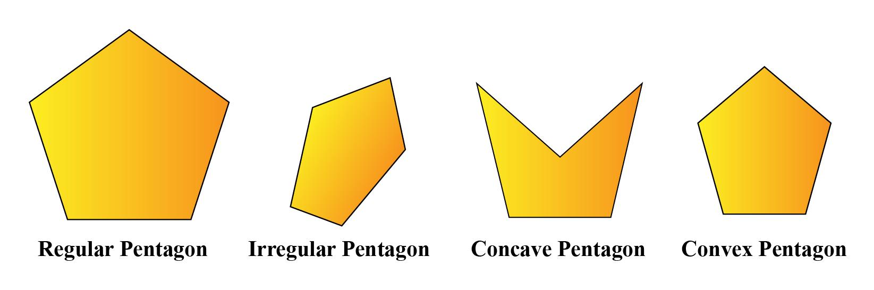

Interior Angle Sum
# Source: AI Source: Provided by: [Data Path: Persons Table -> ID Column: 1, Name_En Column: Motasem Essam] -> From: [ChatGPT] on [7/25/2026]
For any simple pentagon, the sum of its interior angles is:
$$\boxed{\left(n-2\right)×{180}^{∘}}$$
For $n=5$:
$$\left(5-2\right)×{180}^{∘} \\ 3×{180}^{∘} \\ \boxed{{540}^{∘}}$$
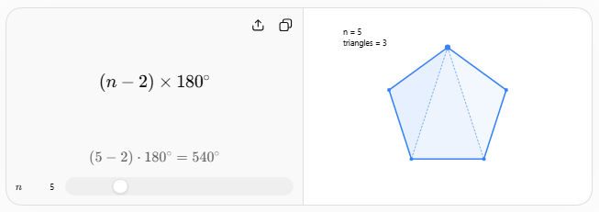
Therefore, for any simple pentagon:
$$\boxed{∠A+∠B+∠C+∠D+∠E={540}^{∘}}$$

Regular Pentagon Angles
# Source: AI Source: Provided by: [Data Path: Persons Table -> ID Column: 1, Name_En Column: Motasem Essam] -> From: [ChatGPT] on [7/25/2026]
For a regular pentagon, all five interior angles are equal.
Therefore:
$$\frac{{540}^{∘}}{5}=\boxed{{108}^{∘}}$$
Each interior angle is:
$$\boxed{{108}^{∘}}$$
Each exterior angle is:
$${180}^{∘}-{108}^{∘} \\ \boxed{{72}^{∘}}$$
The five exterior angles sum to:
$$\boxed{{360}^{∘}}$$

Number of Diagonals
# Source: AI Source: Provided by: [Data Path: Persons Table -> ID Column: 1, Name_En Column: Motasem Essam] -> From: [ChatGPT] on [7/25/2026]
The number of diagonals in an $n$-sided polygon is:
$$\boxed{\frac{n\left(n-3\right)}{2}}$$
For a pentagon:
$$\frac{5\left(5-3\right)}{2}=\frac{5\left(2\right)}{2}=\boxed{5}$$
Thus, a pentagon has:
$$\boxed{5\text{ diagonals}}$$
For pentagon $ABCDE$, they are:
$$\overset{‾}{AC}, \overset{‾}{AD}, \overset{‾}{BD}, \overset{‾}{BE}, \overset{‾}{CE}$$
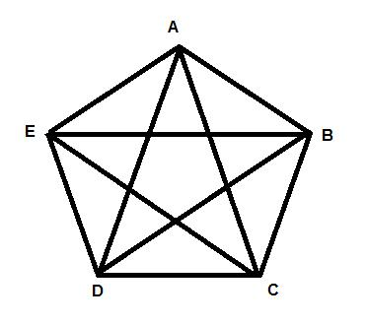
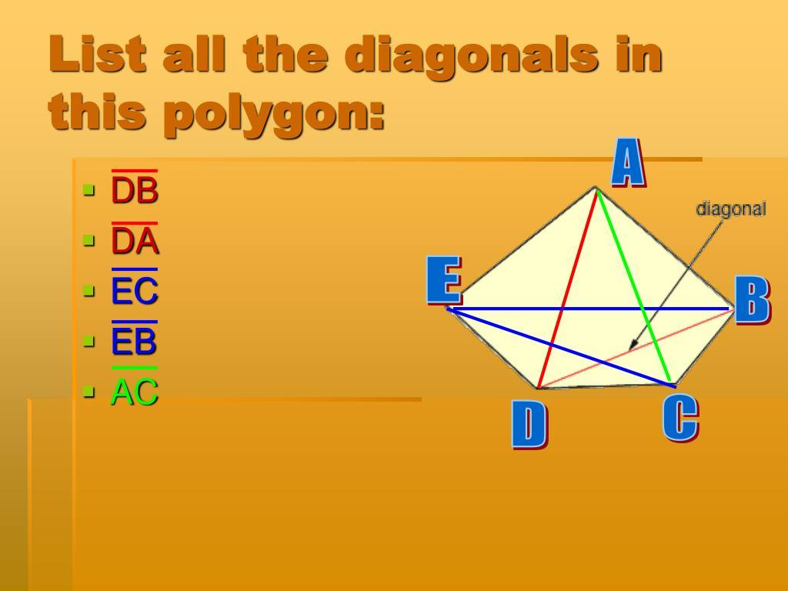
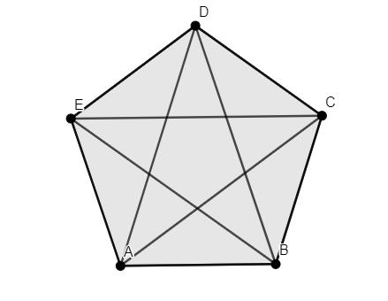

Regular Pentagon Measurements
# Source: AI Source: Provided by: [Data Path: Persons Table -> ID Column: 1, Name_En Column: Motasem Essam] -> From: [ChatGPT] on [7/25/2026]
Let the side length be $a$.
Perimeter
$$\boxed{P=5a}$$
Interior Angle
$$\boxed{{108}^{∘}}$$
Exterior Angle
$$\boxed{{72}^{∘}}$$
Central Angle
A regular pentagon has five equal central angles:
$$\frac{{360}^{∘}}{5}=\boxed{{72}^{∘}}$$
Area
The area of a regular pentagon can be written as:
$$\boxed{A=\frac{1}{4}\sqrt{5\left(5+2\sqrt{5}\right)} a^{2}}$$
Alternatively, using the apothem $r$:
$$\boxed{A=\frac{1}{2}Pr}$$
Since $P=5a$:
$$\boxed{A=\frac{5}{2}ar}$$

Symmetry of a Regular Pentagon
# Source: AI Source: Provided by: [Data Path: Persons Table -> ID Column: 1, Name_En Column: Motasem Essam] -> From: [ChatGPT] on [7/25/2026]
A regular pentagon has:
$$\boxed{5}$$
lines of symmetry.
It also has rotational symmetry of order:
$$\boxed{5}$$
The smallest non-zero angle of rotational symmetry is:
$$\frac{{360}^{∘}}{5}=\boxed{{72}^{∘}}$$

Pentagon and Triangles
# Source: AI Source: Provided by: [Data Path: Persons Table -> ID Column: 1, Name_En Column: Motasem Essam] -> From: [ChatGPT] on [7/25/2026]
A pentagon can be divided into:
$$\boxed{5-2=3}$$
triangles by drawing diagonals from one vertex.
Therefore, its interior angle sum can be understood as:
$$3×{180}^{∘}={540}^{∘}$$
For a convex pentagon, three non-overlapping triangles can be formed from one vertex.
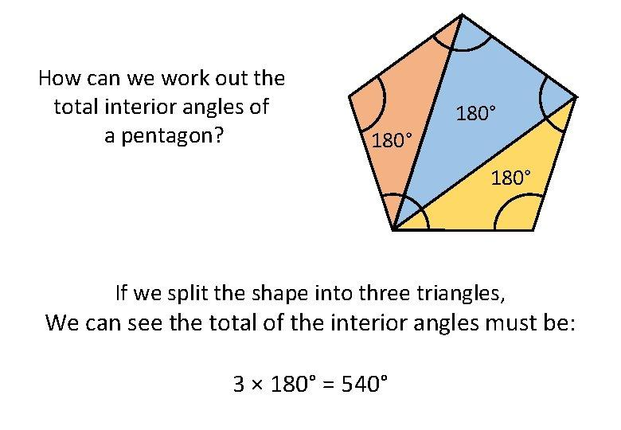
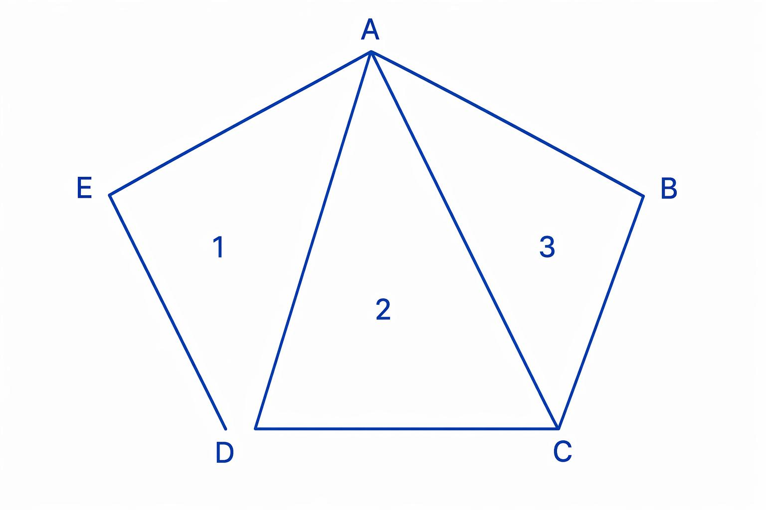
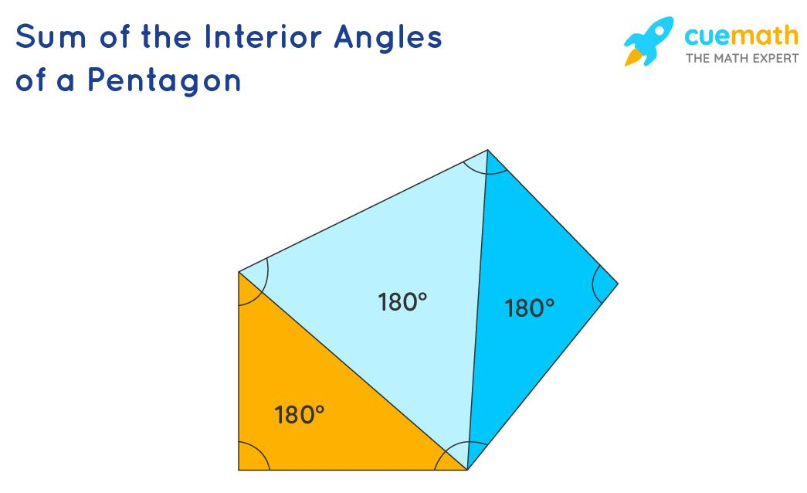

Pentagon Diagonal and Golden Ratio
# Source: AI Source: Provided by: [Data Path: Persons Table -> ID Column: 1, Name_En Column: Motasem Essam] -> From: [ChatGPT] on [7/25/2026]
The regular pentagon has an important relationship with the golden ratio:
$$\boxed{φ=\frac{1+\sqrt{5}}{2}}$$
In a regular pentagon, the ratio of a diagonal to a side is:
$$\boxed{\frac{d}{a}=φ}$$
Therefore:
$$\boxed{d=φa}$$
This relationship is one reason the regular pentagon appears frequently in geometric constructions involving the golden ratio.

Examples

Example 1 — Interior Angle Sum
# Source: AI Source: Provided by: [Data Path: Persons Table -> ID Column: 1, Name_En Column: Motasem Essam] -> From: [ChatGPT] on [7/25/2026]
Find the sum of the interior angles of a pentagon.
$$\left(5-2\right)×{180}^{∘} \\ \boxed{{540}^{∘}}$$

Example 2 — Regular Pentagon
# Source: AI Source: Provided by: [Data Path: Persons Table -> ID Column: 1, Name_En Column: Motasem Essam] -> From: [ChatGPT] on [7/25/2026]
A regular pentagon has side length:
$$a=8\text{ cm}$$
Its perimeter is:
$$P=5\left(8\right) \\ \boxed{P=40\text{ cm}}$$

Example 3 — Missing Angle
# Source: AI Source: Provided by: [Data Path: Persons Table -> ID Column: 1, Name_En Column: Motasem Essam] -> From: [ChatGPT] on [7/25/2026]
Suppose four interior angles of a pentagon are:
$${100}^{∘}, {110}^{∘}, {120}^{∘}, {90}^{∘}$$
Their sum is:
$$100+110+120+90={420}^{∘}$$
Since the total is ${540}^{∘}$:
$$x={540}^{∘}-{420}^{∘} \\ \boxed{x={120}^{∘}}$$

Real-World Applications
# Source: AI Source: Provided by: [Data Path: Persons Table -> ID Column: 1, Name_En Column: Motasem Essam] -> From: [ChatGPT] on [7/25/2026]
Pentagonal shapes appear in:
- architectural designs
- decorative patterns
- floor and wall tiling designs
- logos and symbols
- engineering components
- road and warning signs in some designs
- artistic and geometric constructions
- natural structures and crystallographic patterns

Relationship to Other Polygons
# Source: AI Source: Provided by: [Data Path: Persons Table -> ID Column: 1, Name_En Column: Motasem Essam] -> From: [ChatGPT] on [7/25/2026]
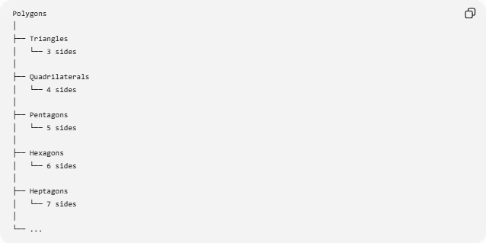
Polygons
│
├── Triangles
│ └── 3 sides
│
├── Quadrilaterals
│ └── 4 sides
│
├── Pentagons
│ └── 5 sides
│
├── Hexagons
│ └── 6 sides
│
├── Heptagons
│ └── 7 sides
│
└── ...
A pentagon is therefore the five-sided polygon.

Key Properties
# Source: AI Source: Provided by: [Data Path: Persons Table -> ID Column: 1, Name_En Column: Motasem Essam] -> From: [ChatGPT] on [7/25/2026]
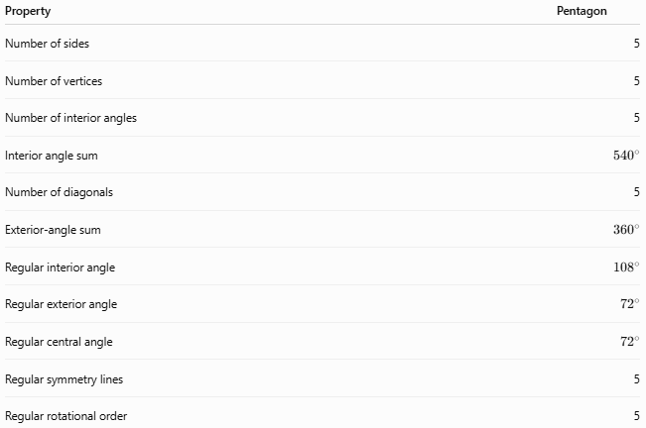
Property | Pentagon
Number of sides | 5
Number of vertices | 5
Number of interior angles | 5
Interior angle sum | $${540}^{∘}$$
Number of diagonals | 5
Exterior-angle sum | $${360}^{∘}$$
Regular interior angle | $${108}^{∘}$$
Regular exterior angle | $${72}^{∘}$$
Regular central angle | $${72}^{∘}$$
Regular symmetry lines | 5
Regular rotational order | 5

Conclusion
# Source: AI Source: Provided by: [Data Path: Persons Table -> ID Column: 1, Name_En Column: Motasem Essam] -> From: [ChatGPT] on [7/25/2026]
A pentagon is a polygon with exactly five sides and five vertices. Its most fundamental properties are:
$$\boxed{5\text{ sides}} \\ \boxed{5\text{ vertices}} \\ \boxed{{540}^{∘}\text{ interior-angle sum}} \\ \boxed{5\text{ diagonals}}$$
A regular pentagon additionally has five equal sides, five equal ${108}^{∘}$interior angles, five lines of symmetry, and rotational symmetry of order $5$.

